Blood Bank Management System

A PROJECT REPORT
Submitted by

Dewangi Sharma [RA2211033010184]
Under the Guidance of

Dr. R. Beaulah Jeyavathana
Assistant Professor, Department of Computational Intelligence

in partial fulfillment of the requirements for the degree of

BACHELOR OF TECHNOLOGY
in

COMPUTER SCIENCE AND ENGINEERING



DEPARTMENT OF COMPUTATIONAL INTELLIGENCE COLLEGE OF ENGINEERING AND TECHNOLOGY SRM INSTITUTE OF SCIENCE AND TECHNOLOGY KATTANKULATHUR– 603 203
MAY 2024



SRM INSTITUTE OF SCIENCE AND TECHNOLOGY KATTANKULATHUR–603 203

BONAFIDE CERTIFICATE

Register no. RA2211033010184 Certified to be the bonafide work done by Dewangi Sharma of II year/IV semester B.Tech Degree Course in the Project Course – 21CSC205P Database Management Systems in SRM INSTITUTE OF SCIENCE AND TECHNOLOGY, Kattankulathur for the academic year 2023-2024.

Date: 3/05/2024

Faculty in Charge
Dr. R. Beaulah Jeyavathana Assistant Professor Department of Computational Intelligence
SRMIST -KTR
HEAD OF THE DEPARTMENT
Dr. R. Annie Uthra
HOD
Department of Computational Intelligence
SRMIST - KTR

ABSTRACT

The Blood Donation System is a robust and user-friendly software application developed to streamline and automate the process of blood donation management. This system is designed to efficiently connect blood donors with recipients, ensuring a timely and organized blood supply chain. The primary goal of the system is to enhance the overall blood donation process, from donor registration to blood distribution, through a well structured and intuitive Python-based platform. The system encompasses a user friendly interface for both donors and administrators. Donors can easily register, update their profiles, and schedule blood donation appointments, while administrators can manage donor records, monitor blood inventory, and coordinate donation drives. The application is built using Python programming language, leveraging its versatility, readability, and extensive support for web development. Key features of the Blood Donation System include real-time inventory tracking, automated notifications for donors and administrators, and a comprehensive database for efficient donor management. The system also incorporates data security measures to protect sensitive donor information. Moreover, the integration of web technologies enables the system to be accessible across various devices, promoting widespread participation and engagement. Through the implementation of this Python-based Blood Donation System, we aim to contribute to the optimization of blood donation processes, making them more efficient, transparent, and accessible to the community. The system serves as a technological bridge between donors and recipients, fostering a culture of voluntary blood donation and ultimately saving lives.

TABLE OF CONTENTS

Chapter No | Chapter Name | Page No
1. | Problem understanding, Identification of Entity and  Relationships, Construction of DB using ER Model for the Project Campus Connect. | 5
2. | Design of Relational Schemas, Creation of Database Tables  for the project Campus Connect. | 6-8
3. | Complex queries based on the concepts of constraints, sets,  joins, views, Triggers and Cursors. | 9-20
4. | Analyzing the pitfalls, identifying the dependencies, and  applying normalizations | 21-25
5. | Implementation of concurrency control and recovery  mechanisms | 26-32
6. | Code for the project | 33-34
7. | Result and Discussion (Screen shots of the implementation  with front end. | 35-38
8. | Appendix | 39

Problem understanding, Identification of Entity and Relationships, Construction of DB using ER Model for the project
Blood banks play a pivotal role in healthcare systems, acting as crucial repositories of lifesaving blood units. However, many blood banks still rely on traditional, manual methods for managing donor information, blood inventory, and distribution. The motivation behind developing a Blood Bank Management System stems from the need to address and overcome the challenges associated with these outdated practices.
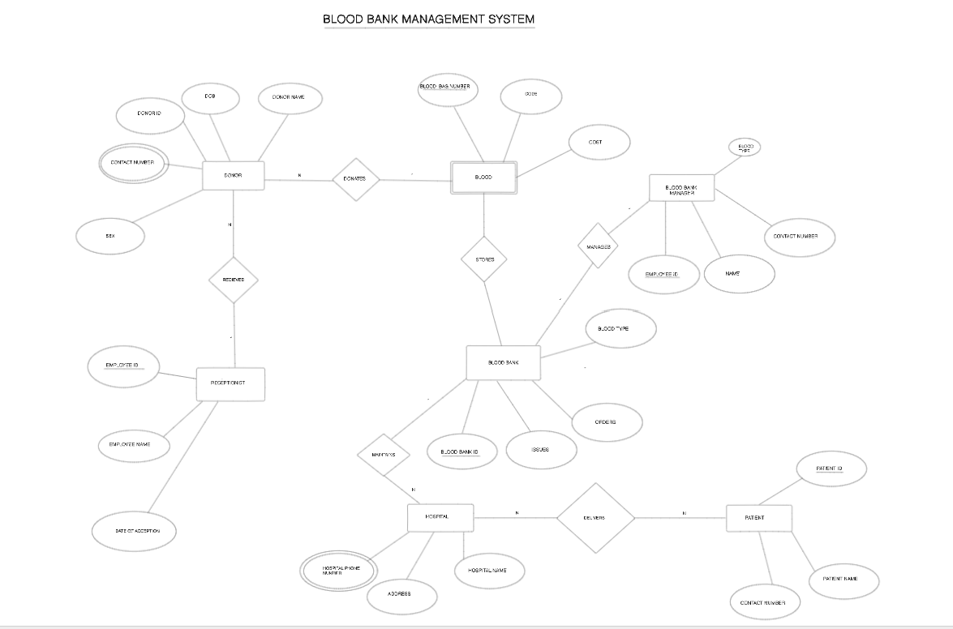

Figure 1.1 - ER Diagram for Campus Connect

5

Design of Relational Schemas, Creation of Database Tables for the project.

Table 2.1 - Donor
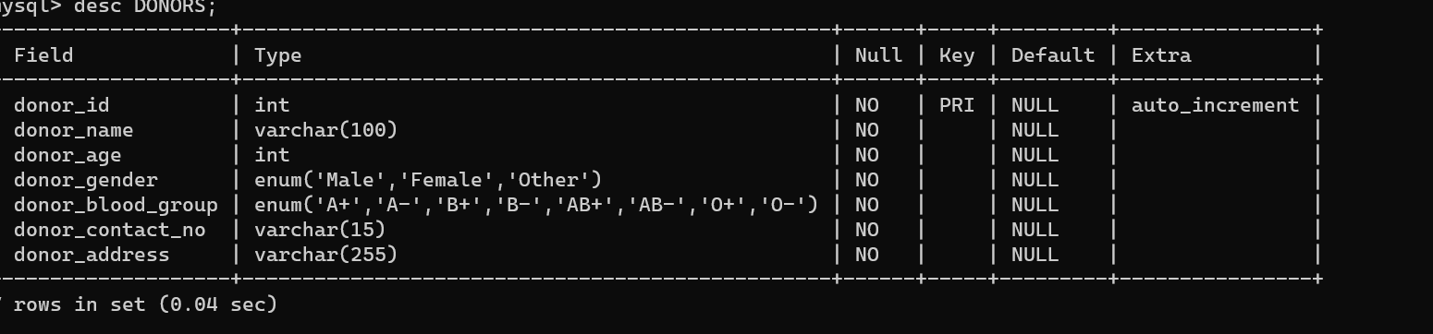

Table 2.2-Blood stock

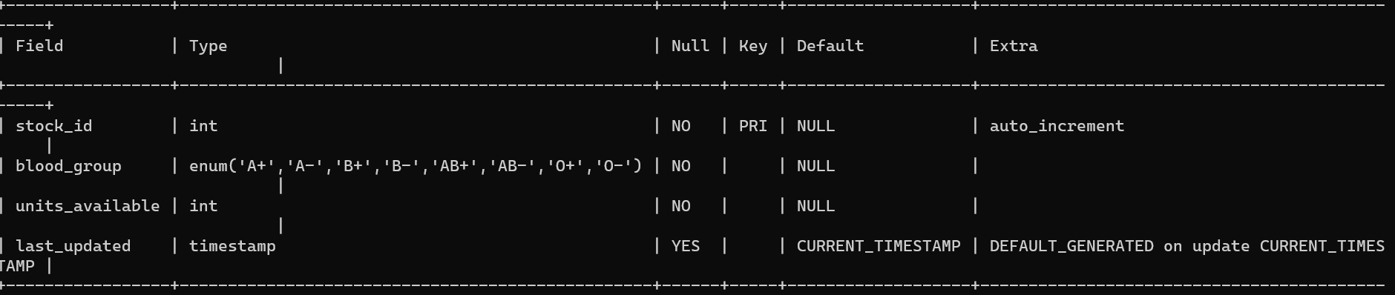

Table 2.3- Receptionist

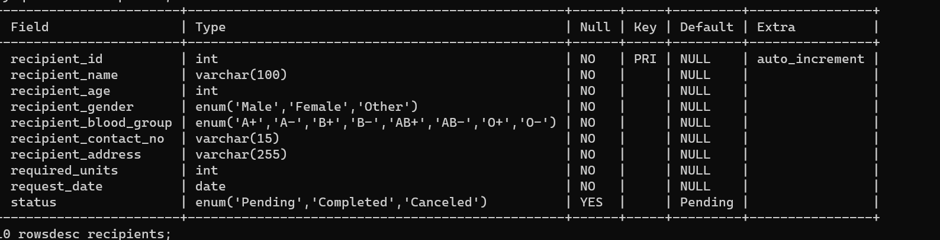
Table 2.4 – Blood Donations
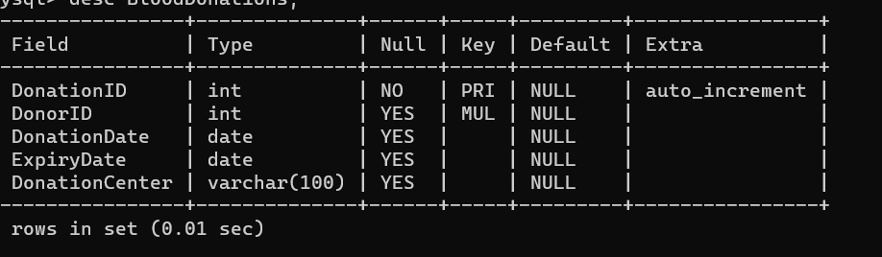

Table 2.5 – Inventory

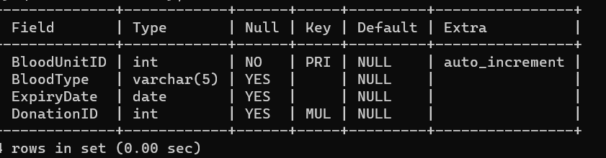

Table 2.6 – Blood Transfusions

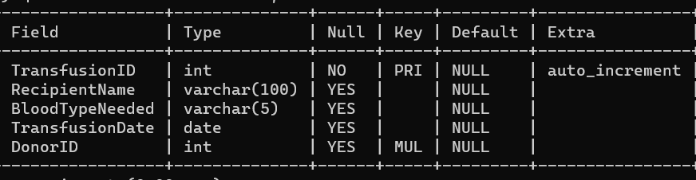

Table 2.7 – Blood Tests

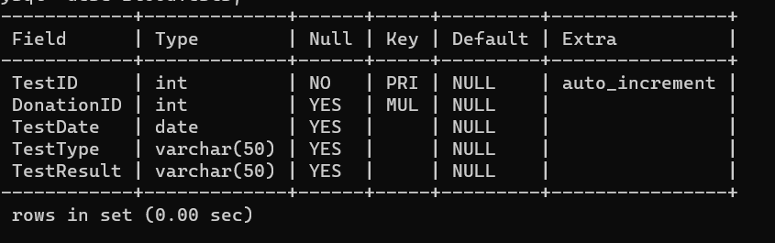

Table 2.8 – Employees

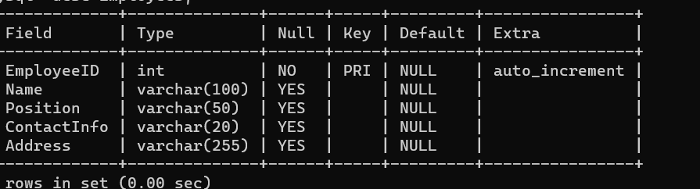

Complex queries based on the concepts of constraints, sets, joins, views, Triggers and Cursors.

Creating Tables

1.CREATE TABLE Donors (
donor_id INT PRIMARY KEY,
name VARCHAR(100),
blood_group VARCHAR(3) CHECK (blood_group IN ('A+', 'A-', 'B+', 'B-', 'AB+', 'AB-', 'O+', 'O-')),
age INT CHECK (age > 17),
weight DECIMAL(5,2) CHECK (weight > 40)
);

2.CREATE TABLE Recipients (
recipient_id INT PRIMARY KEY,
name VARCHAR(100),
blood_group VARCHAR(3) CHECK (blood_group IN ('A+', 'A-', 'B+', 'B-', 'AB+', 'AB-', 'O+', 'O-')),
age INT CHECK (age > 0),
medical_history TEXT
);

3. CREATE TABLE BloodDonations (
donation_id INT PRIMARY KEY,
donor_id INT,
donation_date DATE,
quantity_ml DECIMAL(8,2),
FOREIGN KEY (donor_id) REFERENCES Donors(donor_id)
);

4. CREATE TABLE BloodTransfusions (
transfusion_id INT PRIMARY KEY,
recipient_id INT,
transfusion_date DATE,
quantity_ml DECIMAL(8,2),
notes TEXT,
FOREIGN KEY (recipient_id) REFERENCES Recipients(recipient_id)
);

5. CREATE TABLE BloodInventory (
blood_type VARCHAR(3) PRIMARY KEY,
quantity_ml DECIMAL(12,2)
)

6. CREATE TABLE BloodTypes (
blood_type VARCHAR(3) PRIMARY KEY,
compatible_types VARCHAR(50) -- Comma-separated list of compatible blood types
);

Inserting Values

10: INSERT INTO Donors (donor_id, name, blood_group, age, weight) VALUES (1, 'John Doe', 'A+', 25, 65.5);

11: INSERT INTO Recipients (recipient_id, name, blood_group, age, medical_history) VALUES (1, 'Jane Smith', 'B-', 30, 'None');

12: INSERT INTO BloodDonations (donation_id, donor_id, donation_date, quantity_ml) VALUES (1, 1, '2024-05-06', 450);

13: INSERT INTO BloodTransfusions (transfusion_id, recipient_id, transfusion_date, quantity_ml, notes) VALUES (1, 1, '2024-05-07', 300, 'Emergency transfusion');

14: INSERT INTO BloodInventory (blood_type, quantity_ml) VALUES ('A+', 1500);

15: INSERT INTO DonorMedicalHistory (donor_id, medical_history) VALUES (1, 'No significant medical history');
16: INSERT INTO TransfusionReactions (reaction_id, transfusion_id, reaction_description) VALUES (1, 1, 'Mild fever after transfusion');

17: INSERT INTO BloodTypes (blood_type, compatible_types) VALUES ('A+', 'A+, A-');
18: INSERT INTO BloodComponentTypes (component_id, component_name, description) VALUES (1, 'Whole Blood', 'Contains all blood components');

19: INSERT INTO Donors (donor_id, name, blood_group, age, weight) VALUES (2, 'Alice Johnson', 'B+', 35, 70.2);

20: INSERT INTO Recipients (recipient_id, name, blood_group, age, medical_history) VALUES (2, 'Michael Brown', 'O-', 40, 'High blood pressure');

21: INSERT INTO BloodDonations (donation_id, donor_id, donation_date, quantity_ml) VALUES (2, 2, '2024-05-08', 500);

22. INSERT INTO BloodTransfusions (transfusion_id, recipient_id, transfusion_date, quantity_ml, notes) VALUES (2, 2, '2024-05-09', 400, 'Scheduled transfusion');

23. INSERT INTO BloodInventory (blood_type, quantity_ml) VALUES ('B+', 2000);

24. INSERT INTO DonorMedicalHistory (donor_id, medical_history) VALUES (2, 'Previous blood donation');

25. INSERT INTO BloodTypes (blood_type, compatible_types) VALUES ('B+', 'B+, B-');

Update Table
- Updating Donor's Weight
- UPDATE Donors SET weight = 68.3 WHERE donor_id = 1;

- Updating Recipient's Age
- .UPDATE Recipients SET age = 32 WHERE recipient_id = 1;

- Updating Blood Donation Quantity
- UPDATE BloodDonations SET quantity_ml = 500 WHERE donation_id = 1;

- Updating Blood Transfusion Notes
- UPDATE BloodTransfusions SET notes = 'Urgent transfusion' WHERE transfusion_id = 1;

- Updating Blood Inventory Quantity
- UPDATE BloodInventory SET quantity_ml = 1800 WHERE blood_type = 'A+';

- Updating Donor's Medical History
- UPDATE DonorMedicalHistory SET medical_history = 'Allergic to penicillin' WHERE donor_id = 1;

- Updating Transfusion Reaction Description
- UPDATE TransfusionReactions SET reaction_description = 'Severe allergic reaction' WHERE reaction_id = 1;

- Updating Blood Type Compatibility
- UPDATE BloodTypes SET compatible_types = 'A+, A-, O+' WHERE blood_type = 'A+';

- Updating Blood Component Description
- UPDATE BloodComponentTypes SET description = 'Used for treating burns' WHERE component_id = 1;

- Updating Another Donor's Weight
- UPDATE Donors SET weight = 72.1 WHERE donor_id = 2;

- Updating Another Recipient's Age
- UPDATE Recipients SET age = 37 WHERE recipient_id = 2;

- Updating Another Blood Donation Quantity
- UPDATE BloodDonations SET quantity_ml = 550 WHERE donation_id = 2;

- Updating Another Blood Transfusion Notes
- UPDATE BloodTransfusions SET notes = 'Regular transfusion' WHERE transfusion_id = 2;

- Updating Another Blood Inventory Quantity
- UPDATE BloodInventory SET quantity_ml = 2200 WHERE blood_type = 'B+';

- Updating Another Donor's Medical History
- UPDATE DonorMedicalHistory SET medical_history = 'Previous surgery' WHERE donor_id = 2;

- Updating Another Transfusion Reaction Description
- UPDATE TransfusionReactions SET reaction_description = 'No adverse effects' WHERE reaction_id = 2;

- Updating Another Blood Type Compatibility
- UPDATE BloodTypes SET compatible_types = 'B+, B-' WHERE blood_type = 'B+';

- Updating Another Blood Component Description
- UPDATE BloodComponentTypes SET description = 'Used for clotting disorders' WHERE component_id = 2;

- Updating Yet Another Donor's Weight
- UPDATE Donors SET weight = 65.5 WHERE donor_id = 3;

- Updating Yet Another Recipient's Age
- UPDATE Recipients SET age = 40 WHERE recipient_id = 3;

Select query with aggregate functions and Clauses

-- 1. Query to Calculate Total Number of Donors

SELECT COUNT(*) AS total_donors FROM Donors;

-- 2. Query to Calculate Average Age of Donors

SELECT AVG(age) AS average_age FROM Donors;

-- 3. Query to Find the Youngest Donor

SELECT MIN(age) AS youngest_age FROM Donors;

-- 4. Query to Find the Oldest Donor

SELECT MAX(age) AS oldest_age FROM Donors;

-- 5. Query to Calculate Total Quantity of Blood Donated

SELECT SUM(quantity_ml) AS total_donated FROM BloodDonations;

-- 6. Query to Calculate Average Quantity of Blood Donated

SELECT AVG(quantity_ml) AS average_donation FROM BloodDonations;

-- 7. Query to Find the Largest Blood Donation

SELECT MAX(quantity_ml) AS largest_donation FROM BloodDonations;

-- 8. Query to Find the Smallest Blood Donation

SELECT MIN(quantity_ml) AS smallest_donation FROM BloodDonations;

-- 9. Query to Calculate Total Quantity of Blood Transfused

SELECT SUM(quantity_ml) AS total_transfused FROM BloodTransfusions;

-- 10. Query to Calculate Average Quantity of Blood Transfused

SELECT AVG(quantity_ml) AS average_transfusion FROM BloodTransfusions;

-- 11. Query to Find the Largest Blood Transfusion

SELECT MAX(quantity_ml) AS largest_transfusion FROM BloodTransfusions;

-- 12. Query to Find the Smallest Blood Transfusion

SELECT MIN(quantity_ml) AS smallest_transfusion FROM BloodTransfusions;

-- 13. Query to Calculate Total Quantity of Blood in Inventory

SELECT SUM(quantity_ml) AS total_inventory FROM BloodInventory;

-- 14. Query to Calculate Average Age of Recipients

SELECT AVG(age) AS average_age FROM Recipients;

-- 15. Query to Find the Youngest Recipient

SELECT MIN(age) AS youngest_age FROM Recipients;

-- 16. Query to Find the Oldest Recipient

SELECT MAX(age) AS oldest_age FROM Recipients;

-- 17. Query to Calculate Total Number of Recipients

SELECT COUNT(*) AS total_recipients FROM Recipients;

-- 18. Query to Count the Number of Donors per Blood Type

SELECT blood_group, COUNT(*) AS num_donors FROM Donors GROUP BY blood_group;

-- 19. Query to Count the Number of Recipients per Blood Type

SELECT blood_group, COUNT(*) AS num_recipients FROM Recipients GROUP BY blood_group;

-- 20. Query to Calculate Total Quantity of Blood Transfused per Blood Type

SELECT blood_group, SUM(quantity_ml) AS total_transfused FROM BloodTransfusions

GROUP BY blood_group;

Set Operations

-- 1. Union: Combine all blood donors and recipients
SELECT donor_id, name, blood_group FROM Donors
UNION
SELECT recipient_id, name, blood_group FROM Recipients;

-- 2. Union All: Combine all blood donations and transfusions
SELECT donation_id, donor_id, donation_date FROM BloodDonations
UNION ALL
SELECT transfusion_id, recipient_id, transfusion_date FROM BloodTransfusions;

-- 3. Intersection: Find donors who are also recipients
SELECT donor_id, name, blood_group FROM Donors
INTERSECT
SELECT recipient_id, name, blood_group FROM Recipients;

-- 4. Except: Find donors who are not recipients
SELECT donor_id, name, blood_group FROM Donors
EXCEPT
SELECT recipient_id, name, blood_group FROM Recipients;

-- 5. Union: Combine blood types from inventory and blood types from donors
SELECT blood_type FROM BloodInventory
UNION
SELECT blood_group FROM Donors;

-- 6. Union All: Combine blood types from inventory and blood types from recipients
SELECT blood_type FROM BloodInventory
UNION ALL
SELECT blood_group FROM Recipients;

-- 7. Intersection: Find common blood types in inventory and donors
SELECT blood_type FROM BloodInventory
INTERSECT
SELECT blood_group FROM Donors;

-- 8. Except: Find blood types in inventory not donated by any donor
SELECT blood_type FROM BloodInventory
EXCEPT
SELECT blood_group FROM Donors;

-- 9. Union: Combine all blood types from inventory, donors, and recipients
SELECT blood_type FROM BloodInventory
UNION
SELECT blood_group FROM Donors
UNION
SELECT blood_group FROM Recipients;

-- 10. Union All: Combine all blood types from inventory, donors, and recipients (with duplicates)
SELECT blood_type FROM BloodInventory
UNION ALL
SELECT blood_group FROM Donors
UNION ALL
SELECT blood_group FROM Recipients;

-- 11. Intersection: Find common blood types across inventory, donors, and recipients
SELECT blood_type FROM BloodInventory
INTERSECT
SELECT blood_group FROM Donors
INTERSECT
SELECT blood_group FROM Recipients;

-- 12. Except: Find blood types in inventory not donated or transfused
SELECT blood_type FROM BloodInventory
EXCEPT
SELECT blood_group FROM Donors
EXCEPT
SELECT blood_group FROM Recipients;

-- 13. Union: Combine all donors and their medical history
SELECT donor_id, name, blood_group FROM Donors
UNION
SELECT donor_id, medical_history, '' AS blood_group FROM DonorMedicalHistory;

-- 14. Union All: Combine all donors and their medical history (duplicates included)
SELECT donor_id, name, blood_group FROM Donors
UNION ALL
SELECT donor_id, medical_history, '' AS blood_group FROM DonorMedicalHistory;

-- 15. Intersection: Find donors who have medical history recorded
SELECT donor_id, name, blood_group FROM Donors
INTERSECT
SELECT donor_id, '' AS name, '' AS blood_group FROM DonorMedicalHistory;

-- 16. Except: Find donors without recorded medical history
SELECT donor_id, name, blood_group FROM Donors
EXCEPT
SELECT donor_id, '' AS name, '' AS blood_group FROM DonorMedicalHistory;

-- 17. Union: Combine all blood types and compatible types
SELECT blood_type FROM BloodTypes
UNION
SELECT compatible_types FROM BloodTypes;

-- 18. Union All: Combine all blood types and compatible types (duplicates included)
SELECT blood_type FROM BloodTypes
UNION ALL
SELECT compatible_types FROM BloodTypes;

-- 19. Intersection: Find common blood types and compatible types
SELECT blood_type FROM BloodTypes
INTERSECT
SELECT compatible_types FROM BloodTypes;

-- 20. Except: Find blood types without compatible types listed
SELECT blood_type FROM BloodTypes
EXCEPT
SELECT compatible_types FROM BloodTypes;

Joins

-- 1. Inner Join: Retrieve donors with their corresponding blood types
SELECT d.name, d.blood_group, bt.compatible_types
FROM Donors d
INNER JOIN BloodTypes bt ON d.blood_group = bt.blood_type;

-- 2. Left Join: Retrieve all donors with or without corresponding medical history
SELECT d.name, d.blood_group, dm.medical_history
FROM Donors d
LEFT JOIN DonorMedicalHistory dm ON d.donor_id = dm.donor_id;

-- 3. Right Join: Retrieve all medical histories with or without corresponding donors
SELECT dm.donor_id, dm.medical_history, d.name, d.blood_group
FROM DonorMedicalHistory dm
RIGHT JOIN Donors d ON dm.donor_id = d.donor_id;

-- 4. Full Outer Join: Retrieve all donors and their medical history
SELECT d.name, d.blood_group, dm.medical_history
FROM Donors d
FULL OUTER JOIN DonorMedicalHistory dm ON d.donor_id = dm.donor_id;

-- 5. Self Join: Retrieve donors who have the same blood type
SELECT d1.name AS donor1, d1.blood_group AS blood_type, d2.name AS donor2
FROM Donors d1
JOIN Donors d2 ON d1.blood_group = d2.blood_group AND d1.donor_id != d2.donor_id;

-- 6. Cross Join: Retrieve all combinations of donors and recipients
SELECT d.name AS donor, r.name AS recipient
FROM Donors d
CROSS JOIN Recipients r;

-- 7. Natural Join: Retrieve donors and their medical history with shared columns automatically matched
SELECT d.name, d.blood_group, dm.medical_history
FROM Donors d
NATURAL JOIN DonorMedicalHistory dm;

-- 8. Inner Join with Multiple Conditions: Retrieve donors and their corresponding blood inventory
SELECT d.name, d.blood_group, bi.quantity_ml AS inventory_quantity
FROM Donors d
INNER JOIN BloodInventory bi ON d.blood_group = bi.blood_type AND bi.quantity_ml > 1000;

-- 9. Left Join with Aggregation: Retrieve donors with their total donated quantity
SELECT d.name, d.blood_group, SUM(bd.quantity_ml) AS total_donated
FROM Donors d
LEFT JOIN BloodDonations bd ON d.donor_id = bd.donor_id
GROUP BY d.name, d.blood_group;

Sub queries

-- 1. Subquery to Find Donors with Specific Blood Type
SELECT name, age, weight, blood_group
FROM Donors
WHERE blood_group = (SELECT blood_type FROM BloodTypes WHERE compatible_types = 'A+');

-- 2. Subquery to Calculate Average Age of Donors
SELECT AVG(age) AS average_age
FROM Donors
WHERE donor_id IN (SELECT donor_id FROM BloodDonations);

-- 3. Subquery to Find Recipients with No Medical History
SELECT name, blood_group
FROM Recipients
WHERE recipient_id NOT IN (SELECT donor_id FROM DonorMedicalHistory);

-- 4. Subquery to Calculate Total Quantity of Blood Transfused
SELECT SUM(quantity_ml) AS total_transfused
FROM BloodTransfusions
WHERE transfusion_date >= (SELECT DATE_SUB(NOW(), INTERVAL 1 YEAR));

-- 5. Subquery to Retrieve Donors with the Highest Weight
SELECT name, weight
FROM Donors
WHERE weight = (SELECT MAX(weight) FROM Donors);

-- 6. Subquery to Find Recipients with Specific Blood Type
SELECT name, blood_group
FROM Recipients
WHERE blood_group IN (SELECT blood_type FROM BloodTypes WHERE compatible_types LIKE '%+');

-- 7. Subquery to Retrieve Donors Who Donated the Most
SELECT name, COUNT(*) AS num_donations
FROM Donors
WHERE donor_id IN (SELECT donor_id FROM BloodDonations GROUP BY donor_id ORDER BY COUNT(*) DESC LIMIT 1);

-- 8. Subquery to Find Recipients with the Most Recent Transfusion
SELECT name, transfusion_date
FROM Recipients
WHERE recipient_id IN (SELECT recipient_id FROM BloodTransfusions ORDER BY transfusion_date DESC LIMIT 1);

-- 9. Subquery to Calculate Total Quantity of Blood in Inventory for a Specific Blood Type
SELECT blood_type, quantity_ml
FROM BloodInventory
WHERE blood_type = (SELECT blood_type FROM BloodTypes WHERE compatible_types LIKE '%-');

-- 10. Subquery to Retrieve Donors Who Donated the Least
SELECT name, COUNT(*) AS num_donations
FROM Donors
WHERE donor_id IN (SELECT donor_id FROM BloodDonations GROUP BY donor_id ORDER BY COUNT(*) ASC LIMIT 1);

Views

-- 1. View to Display All Donors
CREATE VIEW AllDonors AS
SELECT * FROM Donors;

-- 2. View to Display All Recipients
CREATE VIEW AllRecipients AS
SELECT * FROM Recipients;

-- 3. View to Display Blood Donations with Donor Information
CREATE VIEW DonationInfo AS
SELECT bd.donation_id, d.name AS donor_name, d.blood_group AS donor_blood_group, bd.donation_date, bd.quantity_ml
FROM BloodDonations bd
INNER JOIN Donors d ON bd.donor_id = d.donor_id;

-- 4. View to Display Blood Transfusions with Recipient Information
CREATE VIEW TransfusionInfo AS
SELECT bt.transfusion_id, r.name AS recipient_name, r.blood_group AS recipient_blood_group, bt.transfusion_date, bt.quantity_ml
FROM BloodTransfusions bt
INNER JOIN Recipients r ON bt.recipient_id = r.recipient_id;

-- 5. View to Display Donors and Their Medical History
CREATE VIEW DonorsWithMedicalHistory AS
SELECT d.*, dm.medical_history
FROM Donors d
LEFT JOIN DonorMedicalHistory dm ON d.donor_id = dm.donor_id;

Triggers

-- 1. Trigger to Update Blood Inventory after Blood Donation

CREATE TRIGGER UpdateInventoryAfterDonation

AFTER INSERT ON BloodDonations

FOR EACH ROW

BEGIN

UPDATE BloodInventory

SET quantity_ml = quantity_ml + NEW.quantity_ml

WHERE blood_type = (SELECT blood_group FROM Donors WHERE donor_id = NEW.donor_id);

END;

-- 2. Trigger to Update Blood Inventory after Blood Transfusion

CREATE TRIGGER UpdateInventoryAfterTransfusion

AFTER INSERT ON BloodTransfusions

FOR EACH ROW

BEGIN

UPDATE BloodInventory

SET quantity_ml = quantity_ml - NEW.quantity_ml

WHERE blood_type = (SELECT blood_group FROM Recipients WHERE recipient_id = NEW.recipient_id);

END;

Analyzing the pitfalls, identifying the dependencies, and applying normalizations

1. Analyzing Pitfalls:
- Data Redundancy: Redundant storage of data can lead to inconsistencies and inefficiencies.
- Data Anomalies: Insertion, update, and deletion anomalies can occur when data is not properly structured.
- Inefficient Queries: Poorly designed schema can result in slow query performance.
- Lack of Data Integrity: Without proper constraints, the integrity of the data may be compromised.
- Complexity: Overly complex schema can make maintenance and querying difficult.
2. Identifying Dependencies:
- Functional Dependencies: Determine which attributes are functionally dependent on others.
- Transitive Dependencies: Identify dependencies where a non-prime attribute is functionally dependent on another non-prime attribute.
- Multi-valued Dependencies: Recognize dependencies where the presence of one attribute determines the presence of another attribute.
3. Applying Normalizations:
Normalization is the process of organizing the attributes and tables of a relational database to minimize redundancy and dependency. The normal forms (NF) are stages of normalization, with each successive normal form addressing specific issues. Here's how normalization can be applied:
- First Normal Form (1NF): Ensure that each column contains atomic values, and there are no repeating groups.
- Second Normal Form (2NF): Eliminate partial dependencies by removing columns that depend on only part of the primary key.
- Third Normal Form (3NF): Remove transitive dependencies by moving non-key attributes that depend on other non-key attributes to their own tables.
- Boyce-Codd Normal Form (BCNF): Ensure that every determinant is a candidate key. It is a stronger form of 3NF.
- Fourth Normal Form (4NF): Address multi-valued dependencies by splitting tables that contain sets of independent multi-valued facts.
- Fifth Normal Form (5NF): Address join dependencies by splitting tables that contain relationships between multiple independent relationships.

Existing Tables:
- Donors (donor_id, name, blood_group, age, weight)
- Recipients (recipient_id, name, blood_group, age, medical_history)
- BloodDonations (donation_id, donor_id, donation_date, quantity_ml)
- BloodTransfusions (transfusion_id, recipient_id, transfusion_date, quantity_ml)
- BloodInventory (blood_type, quantity_ml)
- DonorMedicalHistory (donor_id, medical_history)
- TransfusionReactions (reaction_id, transfusion_id, reaction_description)
- BloodTypes (blood_type, compatible_types)
- BloodComponentTypes (component_id, component_name, description)
Let's apply normalization:
First Normal Form (1NF):
Ensure that each column contains atomic values, and there are no repeating groups.
- Donors (1NF):
  - donor_id (Primary Key)
  - name
  - blood_group
  - age
  - weight
- Recipients (1NF):
  - recipient_id (Primary Key)
  - name
  - blood_group
  - age
  - medical_history
- BloodDonations (1NF):
  - donation_id (Primary Key)
  - donor_id (Foreign Key)
  - donation_date
  - quantity_ml
- BloodTransfusions (1NF):
  - transfusion_id (Primary Key)
  - recipient_id (Foreign Key)
  - transfusion_date
  - quantity_ml
- BloodInventory (1NF):
  - blood_type (Primary Key)
  - quantity_ml
- DonorMedicalHistory (1NF):
  - donor_id (Primary Key, Foreign Key)
  - medical_history
- TransfusionReactions (1NF):
  - reaction_id (Primary Key)
  - transfusion_id (Foreign Key)
  - reaction_description
- BloodTypes (1NF):
  - blood_type (Primary Key)
  - compatible_types
- BloodComponentTypes (1NF):
  - component_id (Primary Key)
  - component_name
  - description
Second Normal Form (2NF):
Eliminate partial dependencies by removing columns that depend on only part of the primary key.
- Donors (2NF):
  - donor_id (Primary Key)
  - name
  - blood_group
  - age
  - weight
- Recipients (2NF):
  - recipient_id (Primary Key)
  - name
  - blood_group
  - age
  - medical_history
- BloodDonations (2NF):
  - donation_id (Primary Key)
  - donor_id (Foreign Key)
  - donation_date
  - quantity_ml
- BloodTransfusions (2NF):
  - transfusion_id (Primary Key)
  - recipient_id (Foreign Key)
  - transfusion_date
  - quantity_ml
- BloodInventory (2NF):
  - blood_type (Primary Key)
  - quantity_ml
- DonorMedicalHistory (2NF):
  - donor_id (Primary Key, Foreign Key)
  - medical_history
- TransfusionReactions (2NF):
  - reaction_id (Primary Key)
  - transfusion_id (Foreign Key)
  - reaction_description
- BloodTypes (2NF):
  - blood_type (Primary Key)
  - compatible_types
- BloodComponentTypes (2NF):
  - component_id (Primary Key)
  - component_name
  - description
Third Normal Form (3NF):
Remove transitive dependencies by moving non-key attributes that depend on other non-key attributes to their own tables.
- Donors (3NF):
  - donor_id (Primary Key)
  - name
  - blood_group
  - age
  - weight
- Recipients (3NF):
  - recipient_id (Primary Key)
  - name
  - blood_group
  - age
  - medical_history
- BloodDonations (3NF):
  - donation_id (Primary Key)
  - donor_id (Foreign Key)
  - donation_date
  - quantity_ml
- BloodTransfusions (3NF):
  - transfusion_id (Primary Key)
  - recipient_id (Foreign Key)
  - transfusion_date
  - quantity_ml
- BloodInventory (3NF):
  - blood_type (Primary Key)
  - quantity_ml
- DonorMedicalHistory (3NF):
  - donor_id (Primary Key, Foreign Key)
  - medical_history
- TransfusionReactions (3NF):
  - reaction_id (Primary Key)
  - transfusion_id (Foreign Key)
  - reaction_description
- BloodTypes (3NF):
  - blood_type (Primary Key)
  - compatible_t

Implementation of concurrency control and recovery mechanisms

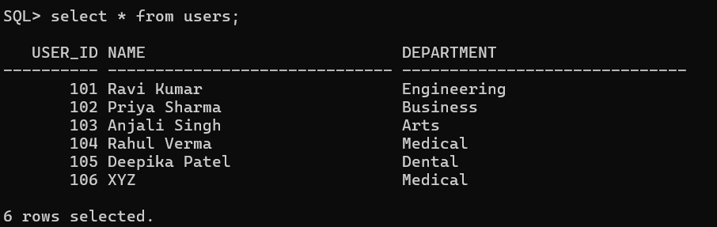
Fig 5.1: Users table before executing any transactions
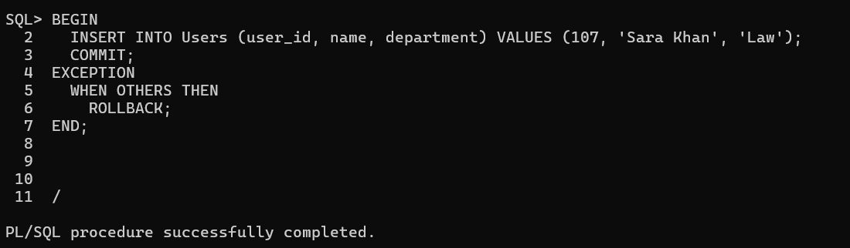
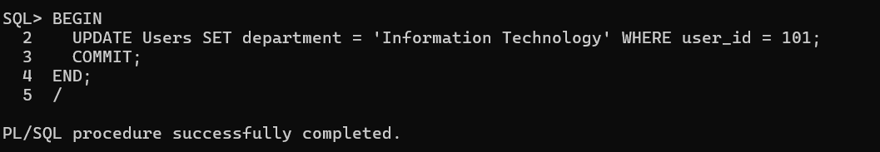
Fig 5.2: Transaction 1
Fig 5.3: Transaction 2
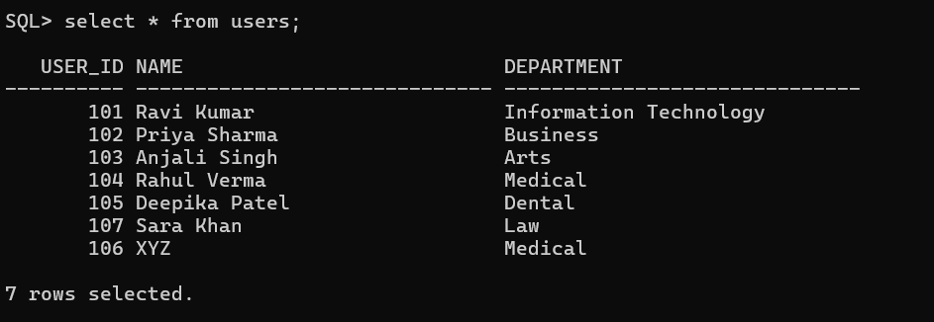
Fig 5.4: Users table after executing the two transactions

Code for the project

#importing modules
from tkinter import *
from tkinter.font import BOLD
import mysql.connector
from tkinter import messagebox

#setting database connection
db = mysql.connector.connect(host ="localhost", user="root", password="root@15", database='db')
# make sure you enter your username and password in the above line
cursor = db.cursor()

# declaring main project window for Python Blood Bank Management System
window = Tk()
window.title("SRM Institute Of Science And Technology Blood Donation Management System")

# Label is a widget in tkinter that implements display box where we can place text
greet = Label(window, font=('arial', 20, 'bold'), text="Welcome to SRM Institute Of Science And Technology!")
greet.grid(row=0, columnspan=3)

# function that alters the database and increase the unit of the blood group
def Donate_dbase():
global bgrp
global bunit
unit = bunit.get()

# Debug statements to check the values,you may comment it
print(bgrp)
print(unit)

# storing sql query in a variable named sqlquery
sqlquery = "Select unit from BloodBank where blood_type='" + bgrp + "';"
# executing the sql query
cursor.execute(sqlquery)

for i in cursor:
print(i[0])
# unit holds the increased amount of the blood group
unit = str(int(i[0]) + int(unit))
print(unit)

# sql query to update the unit of blood group
sqlquery = "Update BloodBank set unit='" + unit + "' where blood_type='" + bgrp + "';"
print(sqlquery)

try:
# finally executing the sql query and updating the database
cursor.execute(sqlquery)
# saving the changes in the database
db.commit()

# displaying the message box showing "Blood Donated S
uccessfully"
messagebox.showinfo('Success', "Blood Donated Successfully")
except:
# if the sql query is not correct or the database connection is not set properly we are displaying a message box displaying "Cannot access Database"
messagebox.showinfo("Error", "Cannot access Database")

# method to ask the unit of blood that the user wants to donate
def donate(*args, **kwargs):
global bgrp
global bunit

# the first value of args holds the blood group, the user wants to donate
bgrp = args[0]
# printing the value of bgrp on command prompt to check if it is correct
print(bgrp)

# initializing a separate tkinter window
window = Tk()
window.title('SRM Institute Of Science And Technology Blood Donation Management System')

# displaying message "Donate Blood"
greet = Label(window, font=('arial', 20, 'bold'), text="Donate Blood")
greet.grid(row=0, columnspan=3)

# ----------bunit------------------

# asking the user to enter the unit of blood, he wants to donate
L = Label(window, font=('arial', 10, 'bold'), text="Enter No. of Unit: ")
L.grid(row=4, column=1)

L = Label(window, font=('arial', 10, 'bold'), text=" ")
L.grid(row=4, column=2)

bunit = Entry(window, width=5, font=('arial', 10))
bunit.grid(row=4, column=3)

# creating a submit button to donate the blood, this button calls Donate_dbase function to update the database.
submitbtn = Button(window, text="Submit", command=Donate_dbase, bg="DodgerBlue2", fg="white", font=('arial', 10))
submitbtn.grid(row=8, columnspan=3)

print("Donate")

# function that alters the database and decreases the unit of the blood group
def Request_dbase():
global bgrp
global bunit
unit = bunit.get()

# Debug statements to check the values,you may comment it
print(bgrp)
print(unit)

# storing sql query in a variable named sqlquery
sqlquery = "Select unit from BloodBank where blood_type='" + bgrp + "';"
# executing the sql query
cursor.execute(sqlquery)

for i in cursor:
# checking if we have sufficient amount of blood present in the blood bank
if int(i[0]) >= int(unit):
# unit holds the updated amount of blood, note that it will be always greater than or equal to zero
unit = str(int(i[0]) - int(unit))
print(unit)

# sql query to update the unit of blood group
sqlquery = "Update BloodBank set unit='" + unit + "' where blood_type='" + bgrp + "';"
print(sqlquery)

try:
# finally executing the sql query and updating the database
cursor.execute(sqlquery)
# committing the changes in the database
db.commit()

# displaying the message box showing "Blood Request Successfully"
messagebox.showinfo('Success', "Blood Request Successful")
except:
# if the sql query is not correct or the database connection is not set properly we are displaying a message box displaying "Cannot access Database"
messagebox.showinfo("Error", "Cannot access Database")
else:
# if the requested amount is not available, showing "Not Available"
messagebox.showinfo("Error", "Not Available")

# method to ask the unit of blood that the user wants
def request(*args, **kwargs):
global bgrp
global bunit

# the first value of args holds the blood group, the user wants
bgrp = args[0]
# printing the value of bgrp on command prompt to check if it is correct
print(bgrp)

# initializing a separate tkinter window
window = Tk()
window.title('SRM Institute Of Science And Technology Blood Donation Management System')

# displaying message "Request Blood"
greet = Label(window, font=('arial', 20, 'bold'), text="Request Blood")
greet.grid(row=0, columnspan=3)

# ----------bunit------------------
# asking the user to enter the unit of blood, he wants
L = Label(window, font=('arial', 10, 'bold'), text="Enter Unit Required: ")
L.grid(row=4, column=1)

L = Label(window, font=('arial', 10, 'bold'), text=" ")
L.grid(row=4, column=2)

bunit = Entry(window, width=5, font=('arial', 10))
bunit.grid(row=4, column=3)

# creating a submit button to request the blood, this button calls Request_dbase function to update the database.
submitbtn = Button(window, text="Submit", command=Request_dbase, bg="DodgerBlue2", fg="white",
font=('arial', 10))
submitbtn.grid(row=8, columnspan=3)

print("Request")

# displaying all the records of the bloodbank table
# sql query to select all the entries of the table
sqlquery = "Select * from BloodBank ;"

try:
# executing the sql query
cursor.execute(sqlquery)

# displaying the table head
L = Label(window, font=('arial', 12, 'bold'), text="%-20s%-20s" % ("Blood group", "Unit"))
L.grid(row=1, column=1)

# x is holding the line number to print the records
x = 4
# iterating over all the records
for i in cursor:
# displaying the blood group type and the amount available
# i[0] is the blood group type
# i[1] is amount
L = Label(window, font=('arial', 10), text="%-20s%-20s" % (i[0], i[1]))
L.grid(row=x, column=1)

bgrp = i[0]

# creating a button to donate blood, here we are using python's lambda function to pass the value of blood group to donate function
d = Button(window, text="Donate", command=lambda arg=i[0], kw="donate": donate(arg, o1=kw), padx=10, pady=10,
bg="DodgerBlue2", fg="white", font=('arial', 15))
d.grid(row=x, column=2)

# creating a button to request blood, here we are using python's lambda function to pass the value of blood group to request function
r = Button(window, text="Request", command=lambda arg=i[0], kw="request": request(arg, o1=kw), padx=10, pady=10,
bg="DodgerBlue2", fg="white", font=('arial', 15))
r.grid(row=x, column=3)

# incrementing x so that all the records are printed in a new line
x += 1

except:
# if the sql query is not correct or the database connection is not set properly we are displaying a message box displaying "Cannot Fetch data"
messagebox.showinfo("Error", "Cannot Fetch data.")
window.mainloop()

Results and Discussion

GUI Blood bank management system

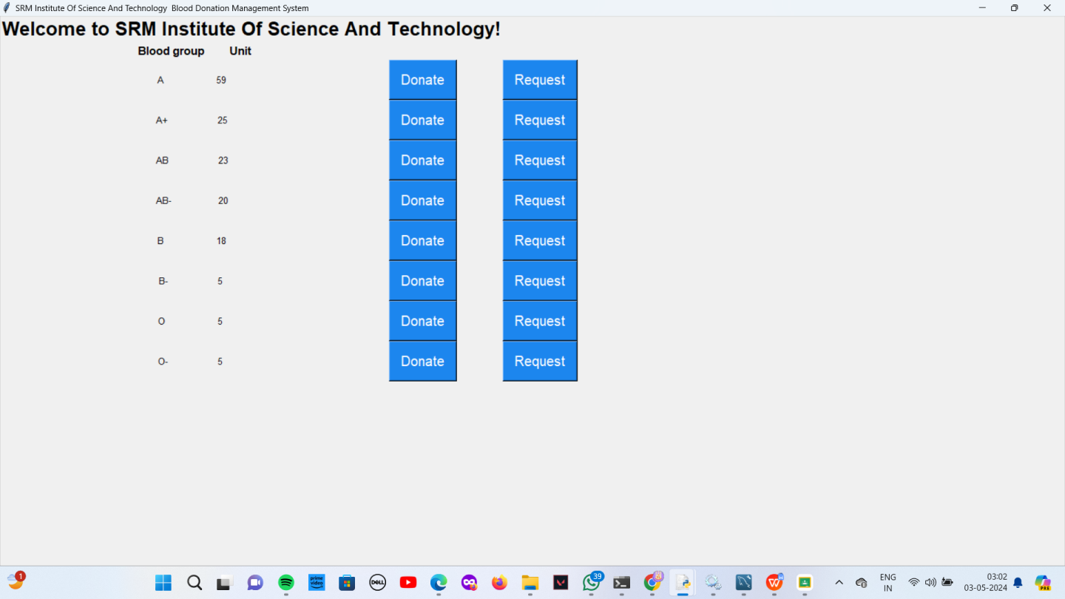

DONATION

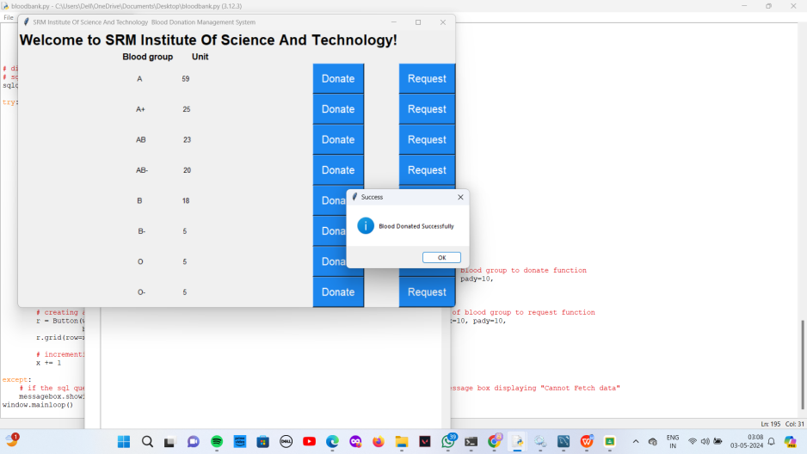

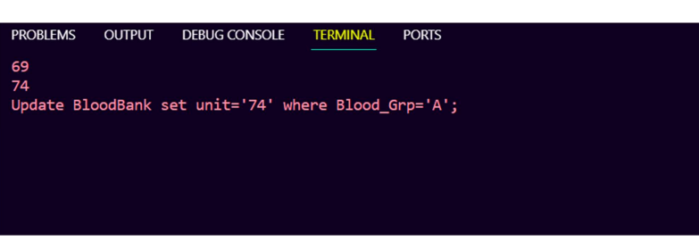

.
REQUEST POP UP
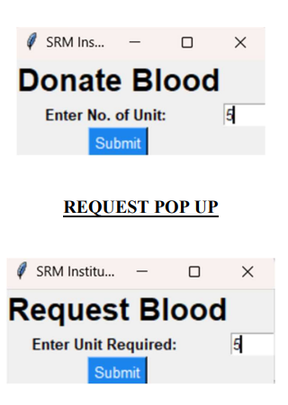

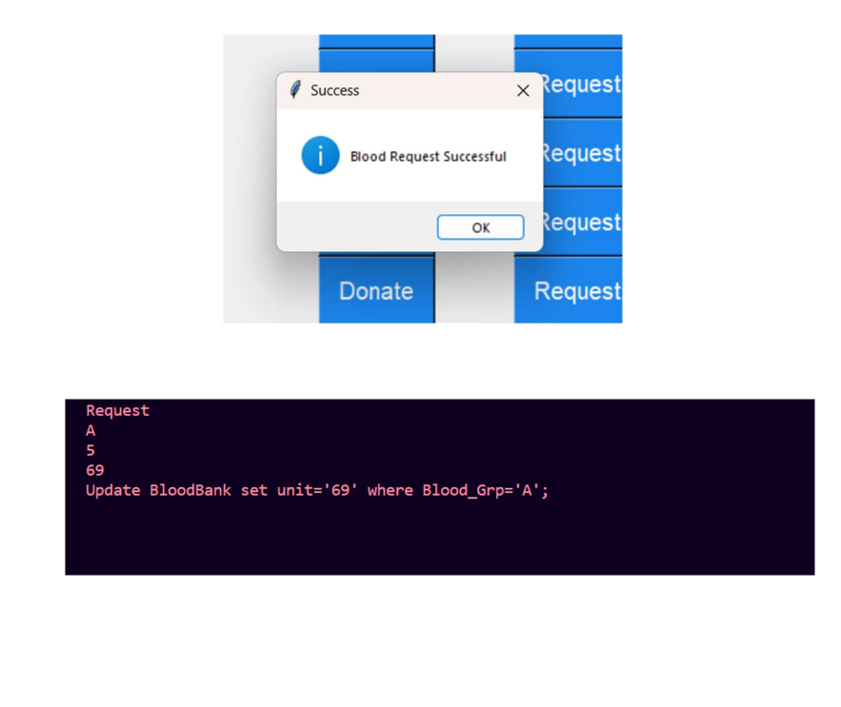
- Appendix

